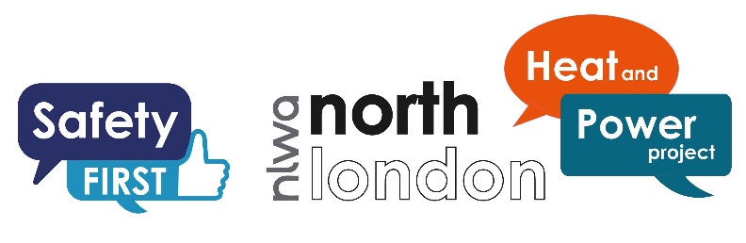
Market Information Event Form
9 October 2019
Company name:

Contact name:

Contact e-mail:

Full postal address:

Phone number:

Mobile:

Are you applying to attend the event in person or via webinar
- In person
- Webinar

Company website URL:

What is your delivery model?*
- Large construction company
- Large construction company which will subcontract the work (please specify the nature of subcontracting below)
- SME Specialist Provider (no subcontracting)
- Other (please specify below)

Further information if request above (Max 100)

Please outline the range of service you offer (max 500 words)

Please comment on any points that your organisation would like to discuss regarding the NLHPP. This will assist us in preparing the generic discussion agenda and give us time to consider your particular points of interest. (max 500 words)

Do you consent to have your company name published online as an attendee at the Market Information Day on October 9th?
- Yes
- No
LINK TO PRIVACY POLICY AND DATA RETENTION POLICY

